Press Release

Zürich, July 8, 2021

**The Altea Long COVID Community went online today, July 8th**

*Since today (July 8th) those affected by Long COVID can exchange ideas and opinions with one another as well as with doctors, therapists and researchers in the [interactive Altea forum](http://www.altea-community.com/). The opening of this Community is the second major step in the development of Altea, the Long COVID Network from Switzerland. Altea bundles current, verified information about Long COVID and networks all relevant actors. Altea aims to improve the situation of those affected by Long COVID.*

The Altea Long COVID Network has been online since April 16. The declared aim of Altea is to promote networking and the exchange of knowledge. The platform is not only aimed at those affected, but also at relatives, doctors, therapists, and researchers.

A lot has happened in these past three months. Numerous [Vademecum](https://www.altea-netzwerk.ch/long-covid/ubersicht-symptome/) with tips on treating symptoms, [blog posts](https://www.altea-netzwerk.ch/blog/) reporting the latest developments and the [stories and experiences](https://www.altea-netzwerk.ch/stories/) from those affected have been published. The [directory](https://www.altea-netzwerk.ch/netzwerk/verzeichnis/) in which specialized clinics, doctors and therapies are listed has also grown. Thanks to the easy-to-sort directory, those affected can quickly and easily find suitable treatment options.

**Starting today: Even more exchange in the Community**

Since the Altea Long COVID Network has been online, the great response and helpfulness from the community has been and is overwhelming. Starting today, Thursday, July 8th, 2021, networking and exchange can take place even more directly on the newly programmed forum ([altea-community.com](http://www.altea-community.com/)). For data protection reasons, the forum is located in a protected member area. The required login can be created quickly and easily. In the forum, those affected, relatives, doctors, therapists, and researchers can exchange ideas and opinions, ask questions, report on therapy experiences, talk about newly discovered knowledge or their needs; everything that is within the scope of a respectful, appreciative approach is allowed.

The French, Italian and English language versions of Altea Network are currently being planned. In the Community, however, discussions can already take place in all national languages ​​and in English.

**The Community revitalizes the co-creation approach**

Altea is based on the co-creation approach. This means that inputs, suggestions, and ideas from the various stakeholder groups are central to the functioning and further development of the platform. The knowledge conveyed by the platform is continuously adapted through this constant exchange, and also on the basis of the latest findings. Researchers, those affected and medical professionals should benefit from each other as much as possible. Thanks to the forum on the Altea Community, this exchange can be intensified and can take place even faster and more directly.

**What is Altea?**

The Altea Long COVID Network was initiated by [LUNGE ZÜRICH](https://www.lunge-zuerich.ch/startseite) and will soon be converted into a suitable support structure. Further partners from the institutional, scientific, and medical fields are to be added over time and contribute to the long-term success of the network. The name Altea is derived from the Greek Althaíā and the Latin Althaea and means "the one who heals" or "the one who takes care".

**Long COVID Syndrome – what do we know?**

A uniform recognized definition of long COVID does not yet exist. In general, Long COVID refers to the long-term consequences after an infection with COVID-19 that cannot be explained by alternative diagnoses and that last longer than four weeks. Long-COVID symptoms include, for example, shortness of breath, chronic fatigue, or joint and muscle pain.

Long COVID can affect anyone, not just members of risk groups or patients with a severe course of COVID-19. Even young, healthy people (including children) can suddenly be affected by symptoms, some of which are severe, after healing from an infection.

There is yet no reliable information about the frequency with which Long COVID occurs. However, even with a cautious estimate, tens of thousands of people in Switzerland could be affected by mild to more severe long-term effects. The [BAG literature](https://www.bag.admin.ch/dam/bag/de/dokumente/mt/k-und-i/aktuelle-ausbrueche-pandemien/2019-nCoV/Literaturrecherchen/literaturrecherchen_long_covid_20210607.pdf.download.pdf/20210607_Literaturrecherchen_Long_Covid_EN.pdf) report therefore expects long-term burdens for the health system and the economy. [More information](https://www.altea-netzwerk.ch/long-covid/was-ist-long-covid/) is available on Altea.

**Lunge Zürich: Hilft. Informiert. Wirkt.**

The association Lunge Zürich has been committed to healthy lungs and a high quality of life for lung patients for more than 100 years. It is the contact point for all questions in the field of lungs, lung health, air and breathing and provides comprehensive services in the consultation and care of people with lung diseases such as COPD, asthma, tuberculosis, or sleep apnea.

With its offer, the association maintains and improves the quality of life of people with lung disease and their relatives and makes an important contribution to the prevention, early detection, and research of lung diseases and to ensuring good air quality.

Back to the roots: With the founding of the Altea Network, LUNGE ZÜRICH is building in the spirit of «Helps. Informs. Works. "on its 100-year-old history. While tuberculosis was the trigger for the foundation in 1908, today the association is in a similar situation with COVID-19.

The Lunge Zurich association is a non-profit organization and operates under the name LUNGE ZÜRICH. [www.lunge-zuerich.ch](http://www.lunge-zuerich.ch)

**Images**

Appropriate images can be downloaded from the following link:

<https://we.tl/t-9H5bWmy8eE>

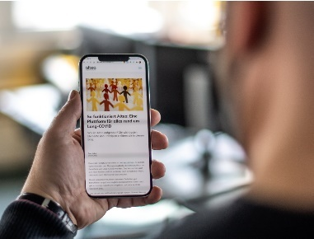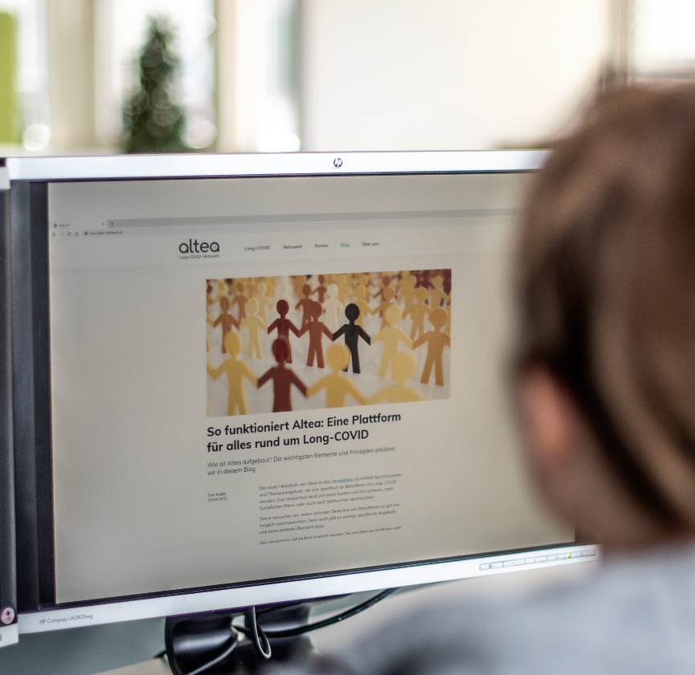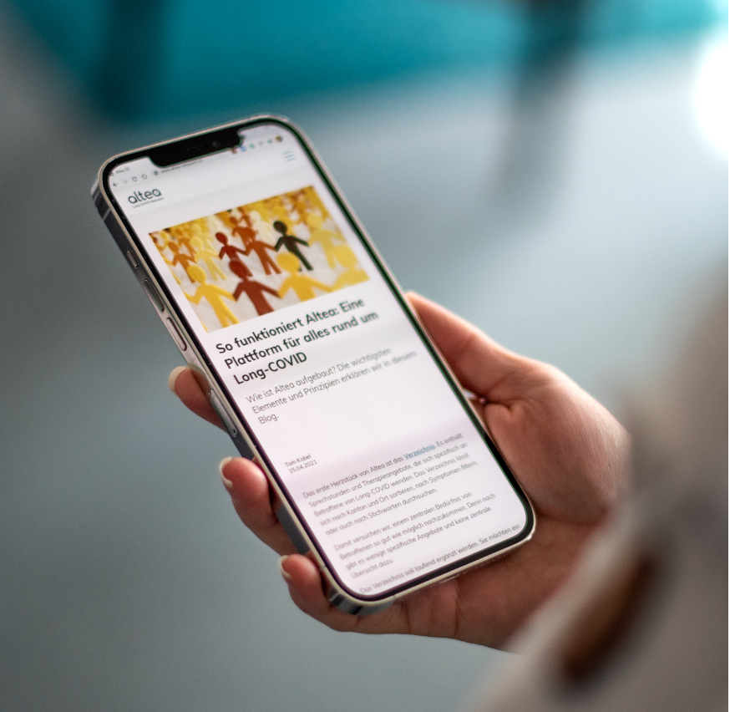

**Altea Long COVID Network_01 Altea Long COVID Network _02 Altea Long COVID Network _03**

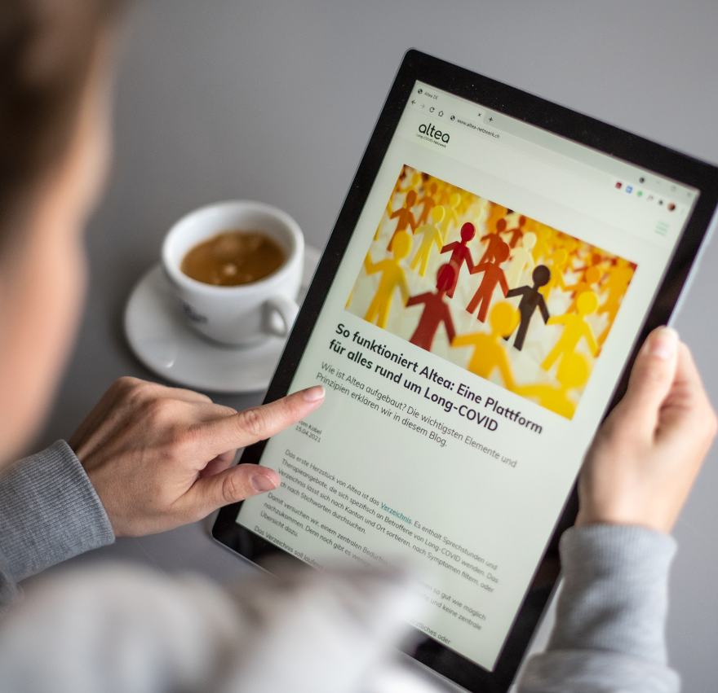

**Altea Long COVID Network _04 Logo** «**Altea – Long COVID Network**» **small & medium**

**Contact**

Claudia Wyrsch, Head of Communication and Marketing

Telephone 044 268 20 08, [pr@lunge-zuerich.ch](mailto:pr@lunge-zuerich.ch)